**TESTEX CEO Challenged Himself Again In trail Running Race**

On November 22, the trail running race in Zhongshan, Guangdong was held as scheduled. Forrest Chiu, CEO of TESTEX, took part in the race and challenged himself again.



Four groups were set up in this trial running competition: 50 Km elite group, 30 Km challenge group, 13 Km experience group, and 5 Km parent-child group.

Just last month, Forrest completed the 81km Gobi challenge for the first time in his life and won the championship. Read [this](https://www.testextextile.com/celebrating-the-holiday-at-the-desert-testex-ceo-won-the-desert-running-champion/) report here.

Prior to this, Forrest's race experience included 42km trekking in the Tengger Desert, 34km off-road race in Zhongshan, and 42.195 km of Dongguan International Marathon.

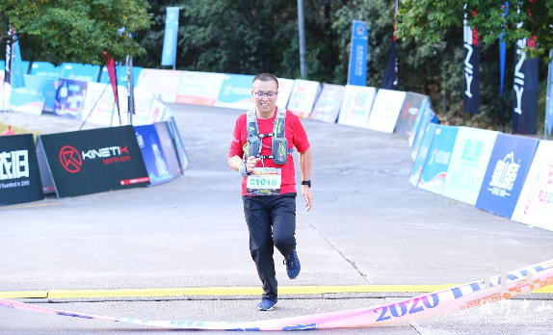

Everyone is curious about why he is so fascinated about challenging himself again in such race.

To find out, we gave Forrest a brief interview.

When Forrest participated in the competition in 2019, he once told himself that he would never be “stupid” again to race in such trial path.

But this year, he ate his words, he ran into the mountains again and participated in the 30 Km challenge group (the same as last year, actually 34 Km).

What impressed him most was the physical experience that after taking part in the competition last year, he went on a business trip to Shanghai to see the exhibition the next day. “Although I watched at the exhibition attentively, it caused a lot of pain after the competition, so I could only move my thighs slowly and move my steps slowly. I watched the exhibition until noon, and couldn't even go to the second floor for lunch.”

In the October Gobi match, Forrest tried his best to win the championship during the GOBI desert race, which also caused a knee ligament strain.

“I couldn't train for more than a month, and only started training two weeks before the event. He said that people are always easy to forget the pain when they are fascinated by something”. He also brought his family and friends, which is his own words is “People who you can count on to be there in weal and woe, are called family and friends”.

There is a coming Marathon in December this year, this is also the reason that brought Forrest to this cross-county race, which he underestimated it as a practice for preparing the coming Marathon, just like most of the participants, thinking that "trial running" is just like the scenery below.

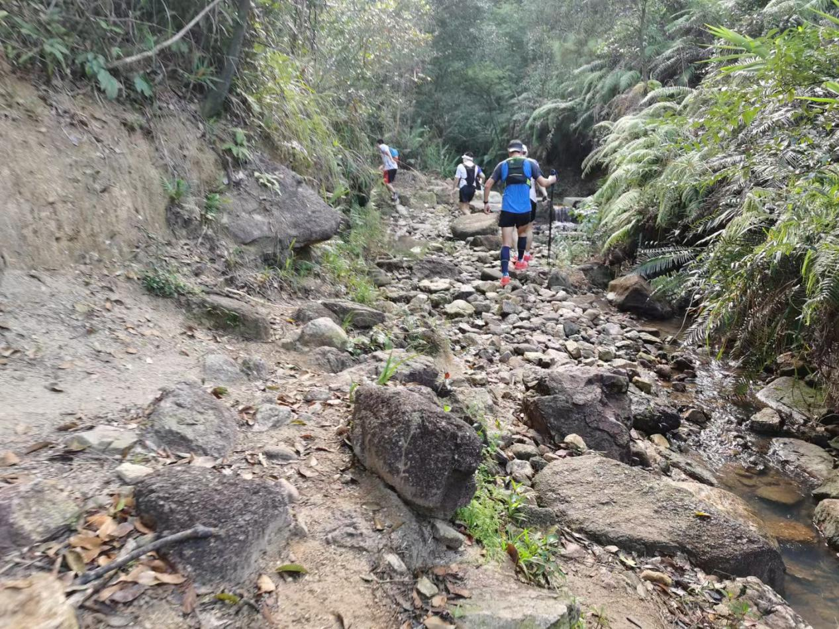

However, they are wrong! Forrest's marathon was completed in 4 hours and 38 minutes, while last year's trail running race was completed in 8 hours and 10 minutes, nearly double the time fo the Marathon.

So, a shorter distance which doesn’t not mean easier to complete, that’s the reason it named cross country.

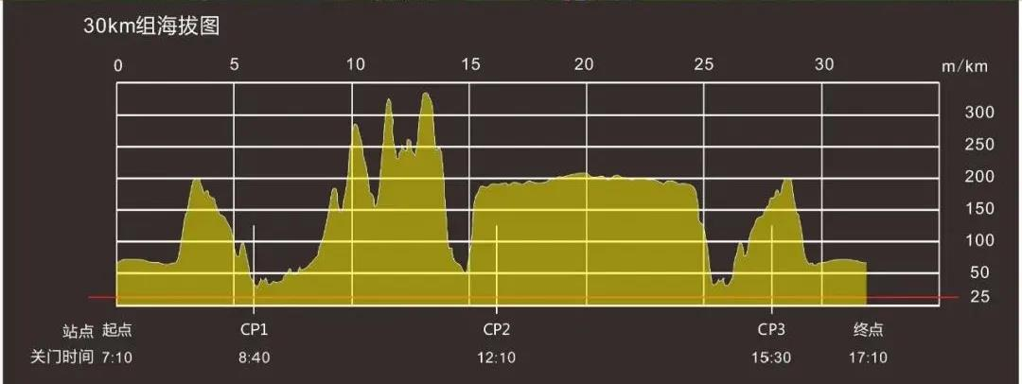

In front of CP1 (check point, also a supply station) is a relatively flat road of 6 kilometers. For a runner like Forrest, it was easy task, but not easy for most people.

Forrest passed CP1 and did not stop after a little replenishment, because the real challenging is waiting ahead.

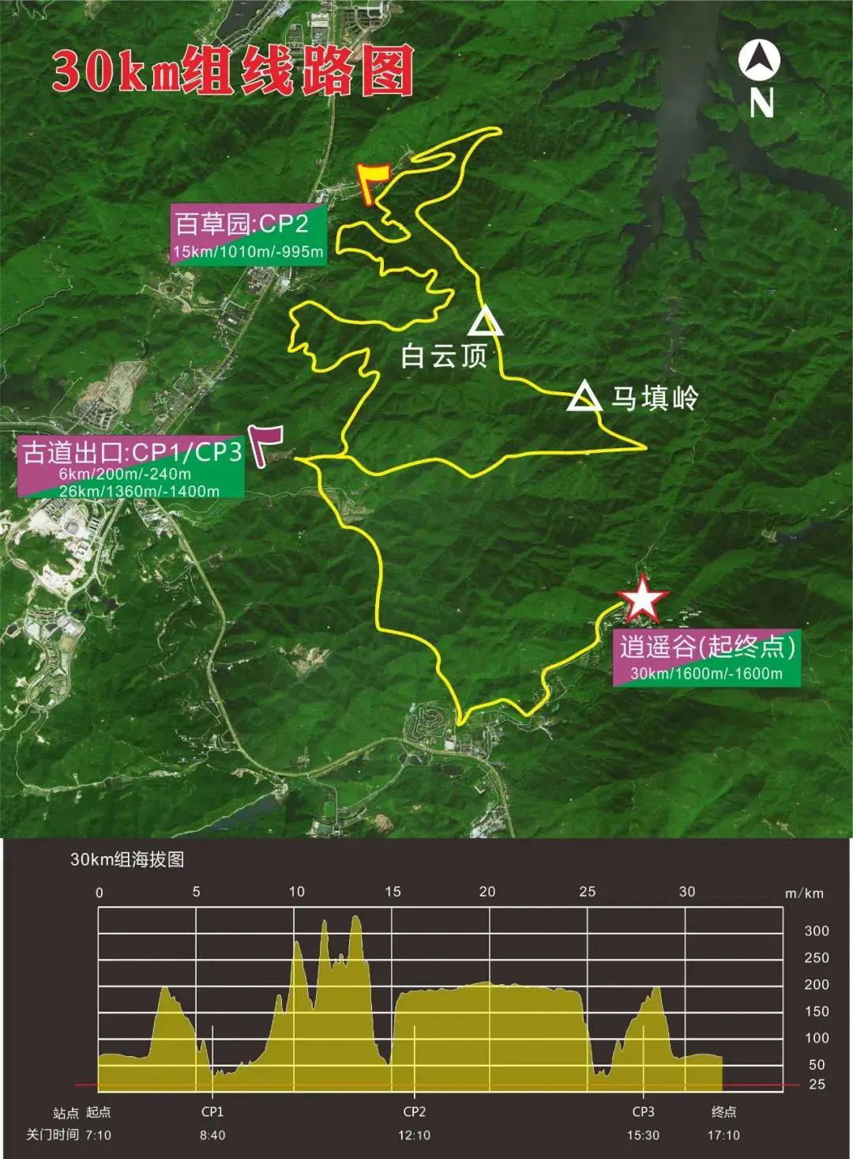

From the distance and altitude chart above, it can be seen that after CP1, it continuously climbs to the top and then rushes down the slope, again and again. Until "Death Slope"... You can know how dangerous it is when you see this name. Last year there were thick ropes tied between the trees so that people could hold them and walk down, but this year there are no ropes...no, the ropes are all broken.

As a result, Forrest fell on this slope. Fortunately, he was lucky enough not to slip down the mountain bottom against his butt. When talking about this after the interview, he said that he couldn't actually slide down, and there is always an oncoming tree that can stop you.

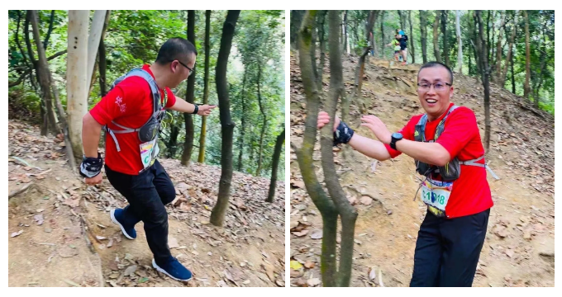

Forrest said with emotion, “This challenging process is just like an entrepreneurial journey.”

Before the competition, there was a picture floating in his mind, imitating the bright and sunny field, and a person passing by in a beautiful running posture.

“Just like the excitement before starting a business, I always feel that I am about to create a great company and become a Fortune 500 company.

During the race, I found that it was not the case at all, the difficulties encountered exceeded expectations, and there was even a possibility of falling short after walking. What to do then, you have to get up quickly, otherwise the people facing you will probably trample on you. Halfway through, I want to give up, but that doesn't work either. There are no rescue teams everywhere in the mountains and forests.”

He said the same is true after starting a business, If you think you have technology or customers, you don't know that this is only one-tenth factors of a successful business. You have to face a series of problems such as brand, talent, finance, quality, taxation, government relations, etc... But once we start, You can’t go back, you can only learn and do it!

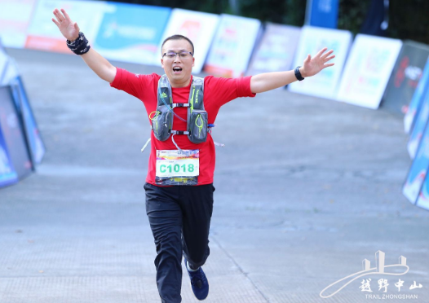

“After each fall, I got up and finally found my own rhythm, but there are teammates who are difficult to catch up in front, and there are opponents who are catching up behind you. Can I relax? I can never accept to be the last one at the end. At this time, you must ensure that the direction **is correct, you have your own rhythm, and you must also have a basis for regular exercise. The most important tip is, even if you are very tired, you must continue to encourage yourself: don't stop, otherwise you will get farther and farther from the people in front, and you may be surpassed by the people behind at any time!**”

“Just like after a stable business, the growth rate will definitely slow down, but as long as the strategic direction is correct, free from external influences, adapt to the current situation and actively change, and the foundation is firmly laid, the last laugh can be achieved.”

“But no matter what, whether it is a person or a company, an end will come definitely, so enjoy the process and make it more meaningful!”

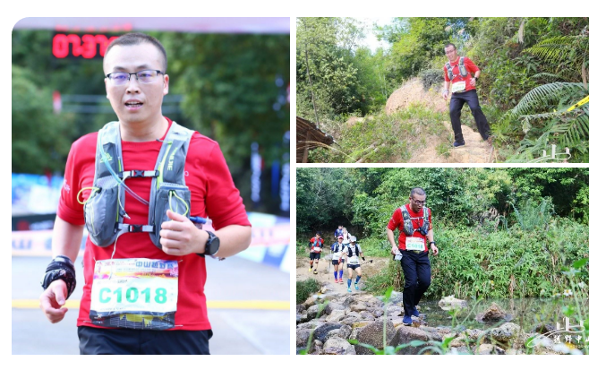

Check to see the video below for a better involving in the total race.



Forrest’s performance in this cross-county race: Ranked 153 among 1500 participants with the time of 7 hours, 28 minutes and 5 seconds, 42 minutes of improvement compared to last-year result.

This off-road race is an unprecedented experience, next year? I am sure he will eat his words again to not attend:)

Although the road is rough, But Forrest's spirit of never giving up is a role model for the staff of all TESTEX employees, which is essential to achieve our vision “To be one of the world’s top 3 manufacturers in textile testing instruments within 5 years.”

Finally, Forrest borrowed a poem from Chairman Mao (Founder of the People's Republic of China, Poet) to summarize the experience:



The pine tree stood proudly on the cliff in the dusk,

and clouds flew by calmly,

A fairy cave is built in the sky,

and it is on this steep mountain to appreciate the infinitely beautiful scenery.

This poem is commonly used to encourage people:

When we are faced with setbacks and adversities on the journey of life, we should be full of confidence in victory, make unremitting efforts, and dare to climb dangerous peaks to win the final victory.